Chicken Business Development Application
Proposal

Executive Summary
This report is submitted in combination with a Dungog Shire Council Development Application form and Statement of Environmental Effects and seeks consent for a small pasture raised chicken egg business. This proposal is for an initial 900 layer hens scaling to a maximum of 2500 birds over 5 years. No new construction is required as the proposed operation will use mobile, non-permanent or existing infrastructure.
Under the current Dungog LEP, this small scale proposal falls under “intensive agriculture” and is permissible with the consent of Council pursuant to Dungog Local Environmental Plan (LEP) 2014.
The siting and management of the proposed operation is in line with industry environmental guidelines to ensure minimisation of any potential amenity or environmental impacts.

Overview of Proposal
This proposal is for the establishment of a pasture raised egg production system to diversify the existing grazing business and introduce a complimentary enterprise. The subject property was purchased by John Monaghan in 2007 and became part of the partnership between John Monaghan and Alan Smith in 2020. 365 Marshdale Rd is now jointly owned by John and Alan
The system is based on mobile housing structures, known as chicken caravans, where the hens roost and lay and range in an area adjacent to the mobile caravans. The mobile chicken caravans, which we will start with 2 and scaling up to 5, are approximately 8m in length and 3m wide. The maximum bird stocking density will be a maximum of 1500 chickens per hectare, with the structure moved around the total egg production area of 25 Ha. This can be compared to cell grazing cattle for optimum pasture growth and soil conditioning.
The business will commence with 900 chickens, producing approximately 400 dozen eggs per week (at peak production) and proposed to scale to a maximum of 2500 chickens producing 1000 dozen eggs per week. This number of birds ensures a financially viable venture servicing the Dungog region, Newcastle and Maitland restaurant and café market as well as online direct customers. Chicken numbers significantly below this figure make it hard to be viable given the high cost of production of this model.
This operation has very limited automation with feeding, watering and egg collection done manually.
Eggs are packed on site with the facilities and processes audited regularly by the NSW Food Authority.
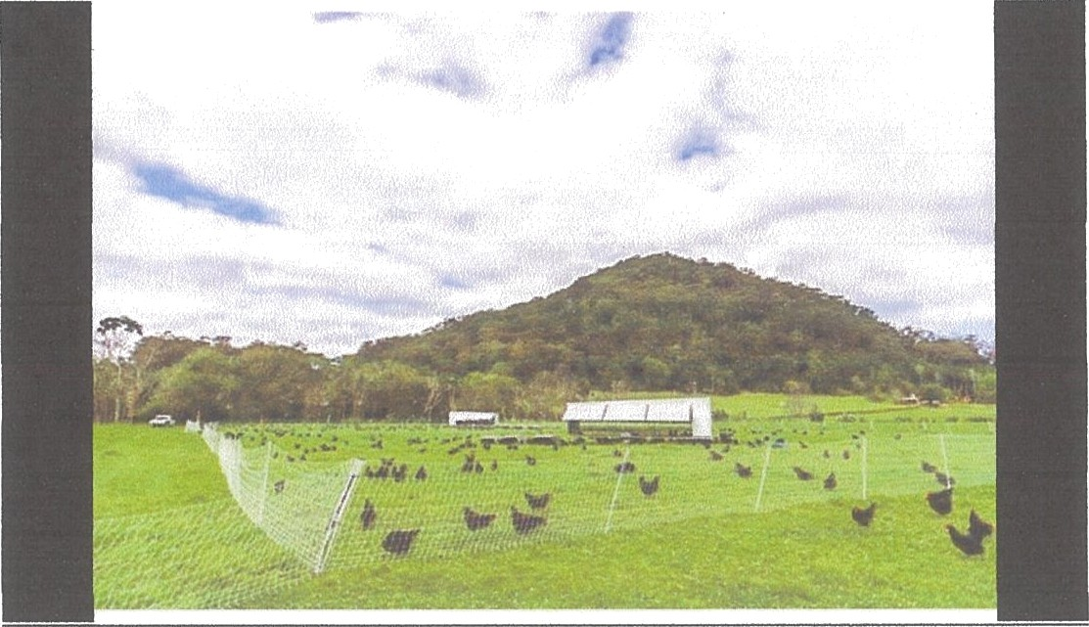
Picture 1. “Waterfall Produce” in northern NSW using 3 caravans that are rotated onto new pasture each week

Subject Site and Locality
Relevant Lot and Plan number:

Lot | Plan
471 | DP1167615
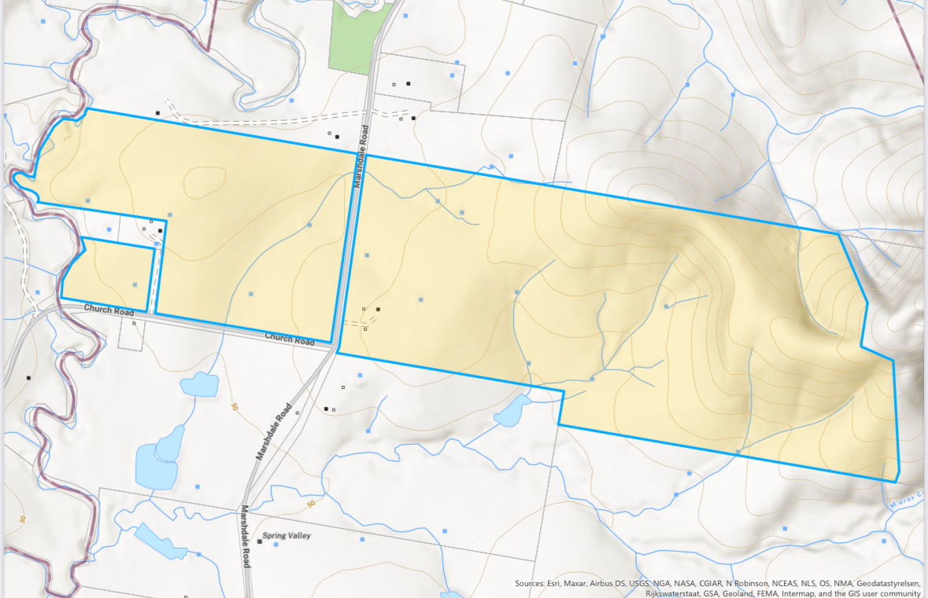
Map 1. Topographic map of 365 Marshdale Rd, Marshdale

This proposal meets the Dungog LEP (2014) RU1 land use zone objectives:
- To encourage sustainable primary industry production by maintaining and enhancing the natural resource base.
- To encourage diversity in primary industry enterprises and systems appropriate for the area.
- To minimise the fragmentation and alienation of resource lands.
- To minimise conflict between land uses within this zone and land uses within adjoining zones.
- To provide for recreational and tourist activities that are compatible with the agricultural, environmental and conservation value of the land.
- To promote the rural amenity and scenic landscape values of the area and prevent the silhouetting of unsympathetic development on ridgelines.
Intensive livestock agriculture is permitted within this zone with consent.
The subject site is large enough to provide for the sustainable operation of the proposed enterprise without adverse impact on community amenities or environment.
This site is located within the Williams River drinking water catchment as identified in the Dungog LEP (2014) catchment maps 2014. As required, the detail in this document will demonstrate that the development is designed, sited and will be managed to avoid any significant adverse impact on water quality and flows.

Statement of Environmental Effects
(Sections as per guidelines on DSC website “Statement of Environmental Effects Guide")

Site Analysis and Existing Use
365 Marshdale Road is 91 ha and is zoned RU1. This is more than adequate for the proposed development, including packing and grading facilities, production area and provides sufficient land around the operation to cater for the Environmental Guidelines for the Australian Egg Industry Australian Egg Corporation Limited - June 2008 with recommended separation distances preventing encroachment by other developments on nearby land.
The property is currently used for extensive grazing, with 40 breeder cows and 40 breeder ewes.
Subject Site
The layer operation will have two primary zones:
  - Egg packing and handling facilities
The egg handling, packaging and storage facilities, including the portable cool room, are located within existing farm building precinct.
No additional permanent structures will be constructed.

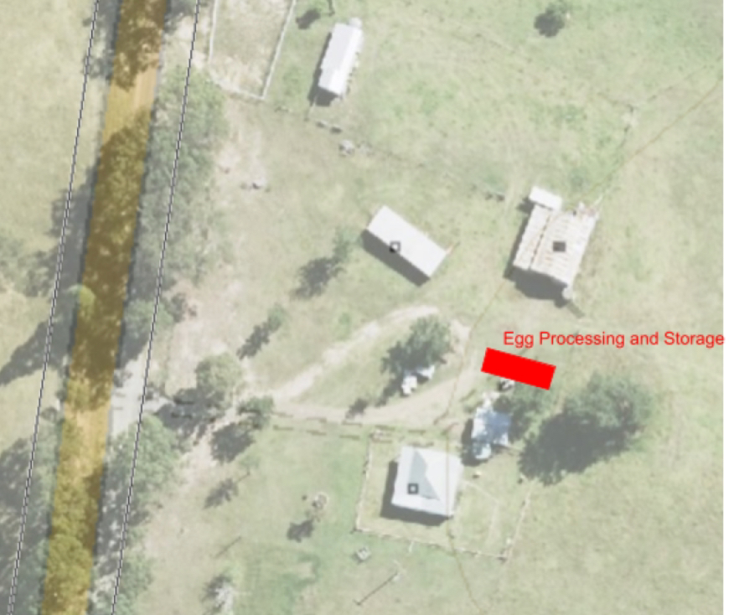

Map 2. Position of Egg Processing and Storage Unit

Bird production area
The bird production area includes the area where mobile chicken caravans will be moved and birds will be rotationally grazed. The total area is approximately 25 ha, relatively level in nature and not within 100m of the Thalaba Creek or designated water course. These areas are within sections of the farm that have been fenced with 13 wire, 900mm high mesh which is wild dog, sheep, cattle and chicken proof.
Stage 1 of the enterprise with the initial 900 birds being housed in 2 chicken caravans and associated equipment will be operated on the West side of Marshdale Rd.

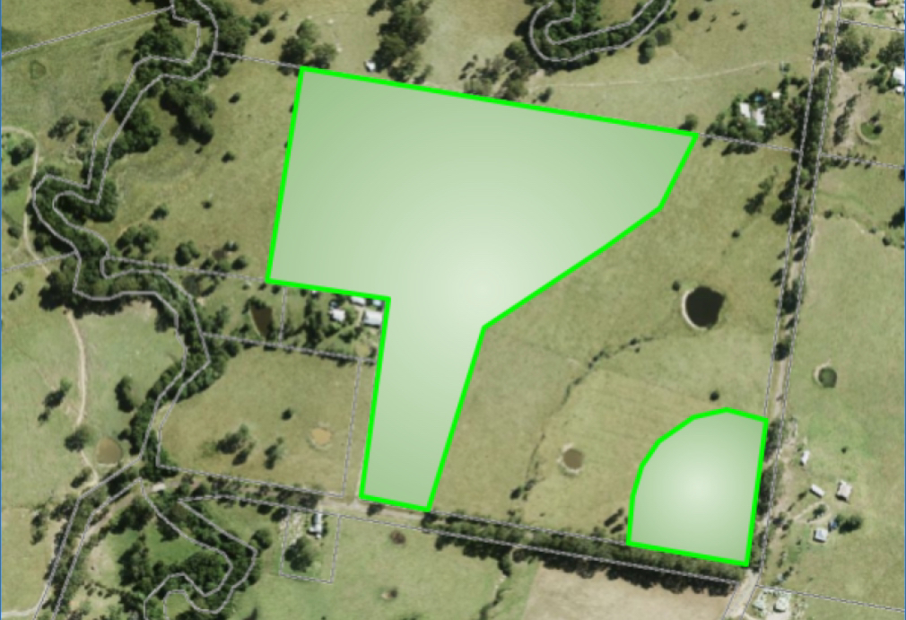
Map3. Designated chicken range west side of Marshdale Rd.
Stage 2 will see the expansion up to 2500 birds housed in a further 3 chicken caravans and associated equipment will be operated on the East side of Marshdale Rd.
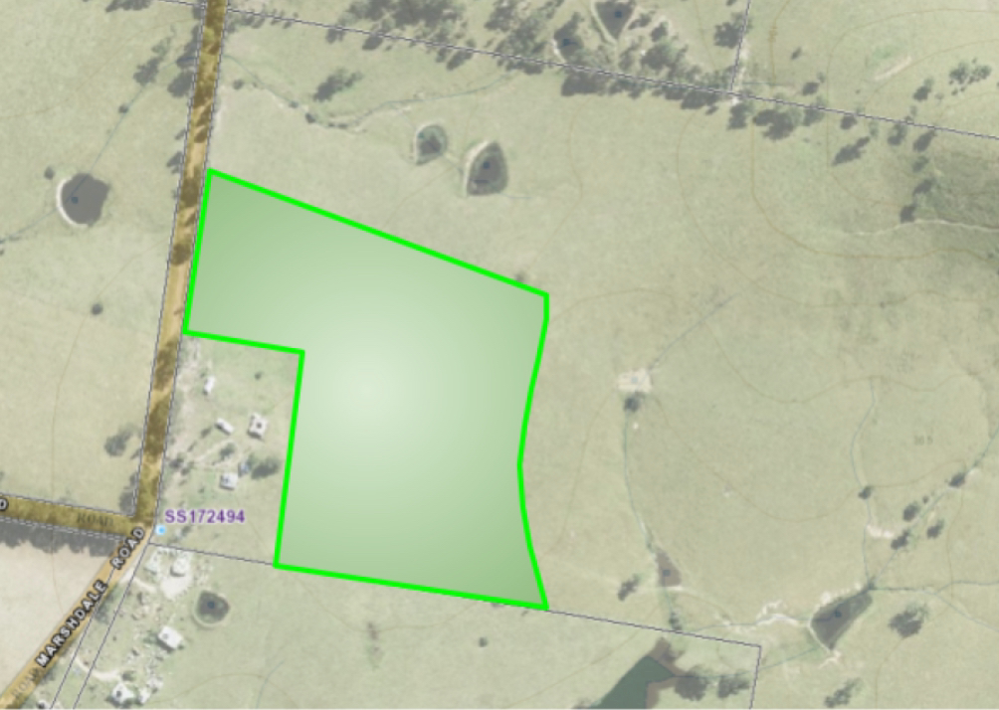
Map 4. Chicken range on East side of Marshdale Rd
The production area meets the following recommended separation distances as stated in the Environmental Guidelines for the Australian Egg Industry

- Water Quality and Ground Water
There will be no adverse effect on water quality as the regenerative farming practices undertaken on Rocking Chair Farm have as a primary principle that 100% ground cover should be maintained at all times. The use of multi species pasture and rotational grazing of all animals (cattle, sheep and chickens) promotes soil microbial activity that improves soil water infiltration and holding capacity thus reducing water runoff and sediment movement. The use of pasture ranged chickens that are moved regularly promotes pasture growth by depositing small quantities of manure evenly across the designated area. This in turn increases plant root growth and further improves soil health and microbial activity.
As a further precaution to minimise nutrient runoff or movement through ground water the chickens will be kept at least 100m from waterways.

Biodiversity

Rocking Chair farm is run as a Holistic farming operation using regenerative farming principles that minismises the use of artificial fertilisers and chemical interventions. We have set aside areas for natural revegetation and undertaken extensive tree planting along water courses, riparian zones and for shade trees. By diversifying stock to include cattle, sheep and pasture fed chickens as part of a sequenced rotational system we can maximise output while ensuring land management practices of 100% ground cover, diverse species mixes and adequate rest periods that lead to improved soil, pasture and animal health.

Biosecurity
We intend to comply with all biosecurity guidelines set out by the DPI and other relevant governing bodies.
There is greater than 1000m between 365 Marshdale Rd and any proposed alternative form of intensive poultry farming and greater than 5000m between any intensive poultry breeder farm.

Amenity
Provide at least 500m between the impact source and any land use zone that is not compatible with the development (e.g. residential zone).

Table 1. Dwellings within 1km of production area boundary:
Address | Owner | Direction from mobile  caravans | Nearest sensitive receptor | Providing letter of support
70 Church Rd | Janet McCormack | Southwest | 450m | Yes
75 Church Rd | Peter and Penny Rain | West | 750m | Yes
79 Church Rd | Nick and Sandy Helyer | West | 300m | Yes
111 Church Rd | Peter and Leigh McGill | Southwest | 150m | Yes
499 Marshdale Rd | Mark Brewer | South | 900m | Yes
421 Marshdale Rd | Peter and Penny Rain | South | 325m | Yes
391 Marshdale Rd | Mark Brewer | South | 275m | Yes
321 Marshdale Rd | Brett Lane | North | 150m | Yes
320 Marshdale Rd | Ian Crawford | North | 250m | Supportive but selling property
311 Marshdale Rd | John Hokin | North | 250m | Had discussions non-committal
281 Marshdale Rd | Lyn Diver | North | 450m | Had discussions non-committal
271 Marshdale Rd | Geraldine Davies | North | 500m | Had discussions non-committal
17 Wattle Tree Lane | Phillipa Nagle | North | 700m | Yes
22 Wattle Tree Lane | Matthew and Jane Moore | North | 580m | Yes
231Marshdale Rd | Brett Thompson | North | 680m | Yes

See attached letters of support

Operational Details
- Egg Production System
The pasture raised egg business has a maximum stocking density of 1500 chickens per hectare. The hens are located in and around a mobile housing structures known as a chicken caravan (approximately 8m in length and 3m wide) that provide shelter and protection for the chickens. Each caravan houses 450 hens and has two 25m2 mobile shade shelters with multiple watering points incorporated and three mobile feeders. These mobile caravans and their associated equipment are moved across paddocks by tractor usually following cattle and/or sheep in a holistic manner constantly ensuring the model code of practice for the welfare of poultry is met or exceeded.
The chickens roam free around the mobile caravans where they shelter, roost and lay eggs. Portable poultry electric fencing will be used to protect the chickens from predators such as foxes and wild dogs. The portable fences are at a radius of at least 50m and up to 200m from the poultry house, which forms the grazing area.
The mobile houses will be rotated through different locations across the 91 hectare property (as indicated by the shaded areas on the site map), with the timing of relocation determined by pasture growth (at least once per week dependent on season) with the aim to maintain high levels of ground cover. This can be compared to cell grazing cattle for optimum pasture growth and soil conditioning.
The chickens are attended daily to replenish water and feed and for eggs to be collected, graded and packed for sale.
Food Authority NSW will conduct ongoing audits of the egg production and handling system to check compliance with the Egg Food Safety Scheme.
- Development / Construction
No new construction is required on site. This application is for:
- the use of a maximum of 2500 chickens in mobile structures moved to various locations across the 91 hectares, and,
- the use of a portable cool room to pack and store the eggs.
Each of the above facilities (the mobile structures and the cool room) can be loaded on to a truck and moved if the business is sold etc. That is, nothing is a permanent fixture - nor is anything constructed on farm for this business proposal.
The Food Authority of NSW must approve the business through an on-site audit before a license to operate can be granted. This audit covers all steps of the process from the storage of feed through to the storing of packed eggs. The Food authority has advised they will only audit the business once chickens are on site to ensure a complete and reliable audit.
- Operational Design
  - Bird Delivery and Removal
Birds will be delivered to the farm by 2-3 tonne, fixed axle truck during daylight hours. There will be one bird delivery every 3-4 months (ie maximum 4 movements per year).
Birds remain in production for 12 months to the age of approximately 70 weeks and are then sold and replaced. At the time of sale, there is the expectation of some individuals arriving to collect chickens.
  - Bird Management and Pasture Maintenance
The design of the mobile structures enables the birds to move freely in and out of the caravan from first light and range on pasture during the day. The birds always have access to supplementary grain feed and fresh water.
Each production unit consisting of the chicken caravan and associated shade, feed and water systems will house a maximum of 450 birds and will be moved around a separate 5ha portion of pasture. With a stocking rate of 1500birds/ha and the units moved weekly it will take a year for the rotation to be completed. That is each area will be grazed by the chickens for 1 week and then get 1 year of rest before the chickens return to that area.
Each production unit will be surrounded by a portable electric fence (see Figure 2). This fence will be moved as the structure is moved to ensure fresh pasture. The shaded areas on the site maps indicate the entire production area and the boundary of where these fences would move over the course of different rotations. As an example, please see Figure 2 below. The blue shaded area Is as per the site map and indicates the total production area that chickens could be rotated on over time. The dotted lines indicate the rotation where the portable electric fence could be moved and the orange square indicates the mobile structure being moved into a new section. The pasture in the old section is then allowed to recover (as per standard cell grazing management practices).


Figure 2: Simple movement of mobile chicken structure across example production area

  - Manure Deposition and Nutrient Management
Many factors influence the birds access to outside areas such as their inherent flock behaviour, fear, comfort, bird status, access to vegetation, food and water. In inclement weather or high ambient temperature, the birds will tend to look for shelter and stay closer to the caravans. By placing water and feeding points away from the caravans will encourage the birds to range more and as most of the manure is deposited while roosting, feeding or drinking the distribution of manure should be more even over the range area.
Moving the caravans and associated equipment weekly will ensure accumulation of manure in any one spot are kept to a minimum.
The estimation of total solids and nutrients has been based on values averaged from digestibility and nutrient balance models using EggBal (not published), (MAF, 2012) and (ASABE, 2005) (LDMOPF, 2020). Nitrogen (N) and Phosphorus (P) are the focus due to their potential environmental implications regarding water quality.
Table 1 Estimated of Total Solids and Nutrients as excreted per bird (Source LDMOPF, 2020)
Species | TS kg/year | VS kg/year | N kg/year | P kg/year | K Kg/yea
Layers | 6.87 | 5.00 | 0.584 | 0.175 | 0.212

Table 2. Estimation of total solids and nutrients for the site
 | TS kg/year | N kg/year | P kg/year
900 | 6,183 | 210 to 420 | 158
2500 | 17,175 | 583 to 1166 | 439
The N figure in the above table assume that N loss to atmosphere is a range between 60% to 20%. For the movable caravan the losses to atmosphere are assumed to be low thus the upper end of range is likely.
Based on the estimation, the expected nutrient across the whole 25ha available ranges are N 23 to 47kg/ha/year and P 17kg/ha/year which are within acceptable agronomic application rates.

Table 3 Estimation of nutrients based on weekly rotation and manure spread (100% under caravan, 50:50 caravan and infrastructure and 50:30:20 caravan, infrastructure and range)
900 birds | N kg/week | P kg/week
100% | 4 to 8 | 3
50:50 | 2:2 to 4:4 | 1.5:1.5
50:30:20 | 2:1:0.8 to 4:2.4:1.6 | 1.5:0.9:0.6
From the above estimations, if the mature was deposited in the same spot for a week, the nutrient additions are very low compared to other grazing livestock such as cattle i.e. 1 cow adds 59kg N/year or 32kg P/year (ASABE< 2005) or 1.1kg N/week or 0.6kg P/week.
If nutrient levels increase to more than soil and vegetation requirements their movement due to surface water runoff in the dissolved form or attached to soil particles in a storm is governed by the topography (slope) of the area and the amount of ground cover. By ensuring that the energy of runoff water is minimised through only using areas where the slope is less than 5 degrees, maintaining ground cover as close to 100% as possible and positioning chicken caravans at least 100m from water course nutrient movement will be negligible.
Chaubey et al. (1995) found in areas amended with poultry manure that vegetation filters reduced TKN by 81% and TP by 91%
Table 4 Estimation of Total Solids and nutrients for site for a ground with 80% ground cover (source AEL, 2018)
Distances from waterway (m) | Estimated residual nutrients
30 | 49%
100 | 9%
200 | 1%
Nutrient load in the areas where the chickens will range will be monitored by taking soil samples annually and analysing for nutrient content to ensure that levels do not exceed plant requirements for healthy growth.
  - Egg Collection and Packaging
Eggs are collected by hand from chicken caravan once per day and moved to that packing area via vehicle.
Egg packing, grading and storage will be undertaken in a portable cooled container facility (see map 4) before delivery to Dungog, Maitland and Newcastle 1-2 times per week in a small van or station wagon.
  - Management of dead birds
Dead birds will be removed daily and frozen in a dedicated 100l chest freezer with capacity for up to 50 birds. This will allow birds to buried in batches when weather conditions are favourable.
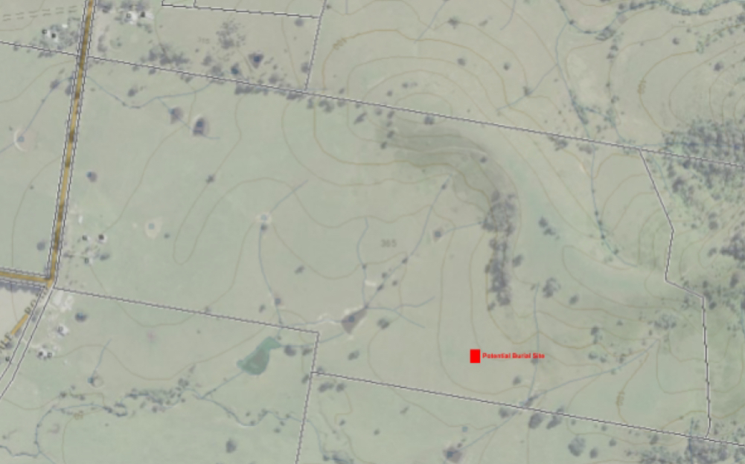
Map 5. Location of burial site
Burials done as per EPA guidelines and the management practices will include:
- Ensuring the base of the burial site is always at least 2 m above the water table. Preventing surface or sub-surface seepage from the pit or trench that may cause the spread of disease or release of contaminants.
- Covering each batch of dead birds with soil or other suitable material.
- Covering full pits with at least 0.5 m of compacted clay soil.
- At an estimated mortality rate of 15% over the life of the flock, the number of dead birds will be on average 1/day when at maximum flock size of 2500 birds.
- At 2kg/bird the total carcass disposal weight on site will be approximately 750kg/year.
If there is a mass mortality occurs the disposal will be directed by Department of Primary Industries and Regional Development (DPIRD) and disposal options could include onsite burial depending on scale and prevailing conditions or offsite disposal by arrangement to a suitable licenced landfill.

- Waste and cleaning at end of 12-month cycle
At the completion of the 12-month cycle once the birds have been removed and sold, the mobile houses will be cleaned by high pressure water hose and disinfected before restocking. This operation will be performed in the house paddock close to clean water and power supply, (See map 4). Due to manure being spread when the chooks roam free, manure residue is kept to a minimum in this cleaning phase. For information, each mobile house has an open grate floor so that manure does not collect inside the caravan when birds are inside.
No stockpile of litter will be created and therefore does not need management.
- Noise
No noisy operation will be a part of the daily farm operation. All operations will take place during the day. Small scale farms do not operate large ventilation fans or other infrastructure which is normally the source of noise for large scale operations.

- Odour
Odour on small scale farms is low/negligible and a risk management strategy of maintaining separation distances of more than 100m from the nearest sensitive receptor not associated with the development will ensure no adverse impact of the amenity of the neighbours.
Odour is also minimised by the housing environment. Unlike large scale sheds there will be no litter or bedding and the mobile caravan environment will be clean and dry. Mobile caravans will be rotated frequently to new locations resulting in no areas becoming odorous.
- Dust
Nil/ negligible.
Housing structures will be moved frequently to maintain pasture cover.
- Hours of Business
This business will operate as it does now with no traffic movements or farm operations outside of daylight hours expected.
- Inputs and Storage Areas
This is a very small business operation with very limited automation and inputs. The maximum size of delivery vehicles will be by small truck, during daylight hours, and with expected vehicle movements associated with deliveries being one per week. Major input sourced from offsite include:
  - Chicken
  - Chicken feed
  - Packaging
All inputs will be stored in appropriate facilities that exist on site or in mobile facilities (chicken caravans and cool room).
Egg storage and handling facilities will be regularly audited by NSW Food Authority for compliance with regulations.
- Disease Management and Animal Welfare
The farm will comply with industry guidelines for biosecurity and animal welfare. The implementation of good management practices will help to minimise the risk of introducing diseases to the flock and spreading to wildlife. Management practices will include:
- Ensuring food and water is not attractive to wildlife
- Treating any surface water used to a potable standard
- Requiring strict adherence of people entering a poultry farm to the biosecurity protocols of the farm to avoid cross contamination
- Ensuring birds are sourced from a certified supplier with comprehensive vaccination program in place
- Proper disposal of dead birds as per EPA guidelines
- Proper controlling of rodents and feral animals
- Minimising contact between animals and wild birds with poultry.
Adequate ventilation, feeding and water systems are necessary for maintaining bird health and welfare. Complete access to the outdoors, additional shade and misting systems will ensure bird welfare is maintained.

Access and Traffic
The proposed egg business will involve a few additional vehicle movements, with mostly light traffic, during daylight hours. Traffic movements on site include:
- Delivery of chickens — by light truck (Total movements = 4 trucks/year)
- Removal of birds — by light truck or light vehicular traffic (Total movements = 4 trucks/year or small amount of light vehicular traffic to collect chickens)
- Delivery of eggs — a small van or station wagon 1-2 times per week delivering the eggs to market. This is not an additional traffic movement as delivery will take place on normal route to Newcastle for personal reasons (No additional)
- Delivery of stock feed — once a week with other farming deliveries therefore up to 50 times per year
Total additional traffic movements because of the business proposal is 60 (120 including return trips) per year. All traffic movements are made during daylight.

Utility Services and Waste Disposal
No additional utility services or waste disposal are required for this project beyond what is already available.
- Water Supply
No additional water infrastructure is required. Water is sourced from an existing on-farm dam and pumped into a 22,000 litre holding tank. This water is currently used for water troughs for our cattle and sheep operations
Laying hen peak drinking water requirement is 400 mL/bird/day (Model Code of Practice for the Welfare of Animals - Domestic Poultry (4th edition)). Thus, maximum daily requirements for 2500 birds will be 1,000 litres, or 365,000 litres per year.
A limited amount of water may additionally be used for bird cooling.

Bird drinking water will be treated in accordance with industry biosecurity protocols with ongoing monitoring and recording.
The contingency plan for bird drinking water supply is the purchase and delivery via water cart.

Power Supply
No additional power infrastructure is required.
Energy Efficiency Solar panels on each mobile house provide all necessary power to operate the
timed nesting boxes within the chicken caravans.

Privacy Views and Overshadowing
There will not be any overshadowing from the mobile chicken caravans, however they will be visible from a couple of the neighbouring residences. Those neighbours have stated they have no concerns about the operations.

Flooding and Drainage
Mobile chicken caravans and associated equipment will be located on land not subject to flooding and 100m from designated water courses.
During prolonged high rainfall events it is proposed to move the chicken caravans to designated areas where hard stands will be provided. This hard stand will allow the caravans to be parked until weather conditions are moderate and will allow for the collection of accumulated manure so that it can be stored in stockpiles and distributed to other areas of the farm when conditions are suitable.
Practicing Regenerative Farming principles, it is a key mantra that we always maintain as close to 100% ground cover as possible. This has the benefit of increasing water infiltration and reducing runoff as well as capturing nutrients and sediment.
The water courses adjacent to the chicken ranges have all had their riparian zones fenced off. This zone approximately 10m wide either side of the water course has been planted with native trees (approximately 2,000 over the last 4 years) as well as allowing dense ungrazed grass vegetation to grow. This has been proven to be the most effect filtration system for the prevention of nutrients and sediments from entering the water catchment system.
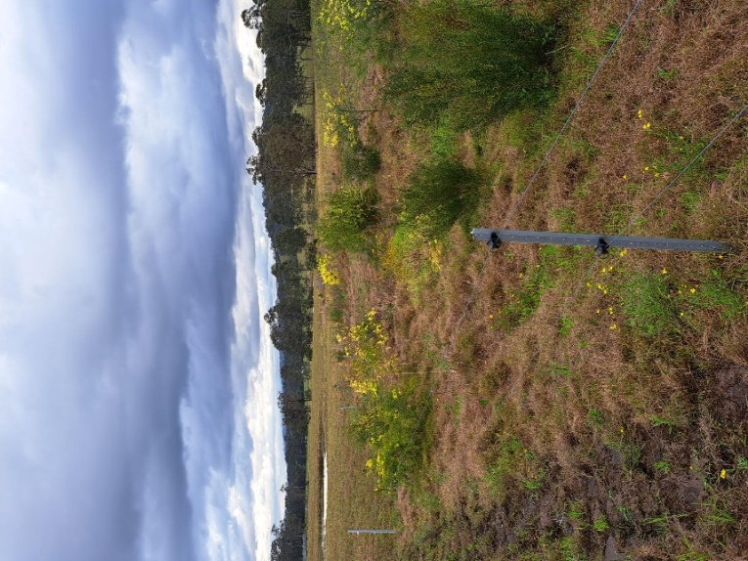
Picture 2. Riparian restoration on water course on the east side of Marshdale Rd

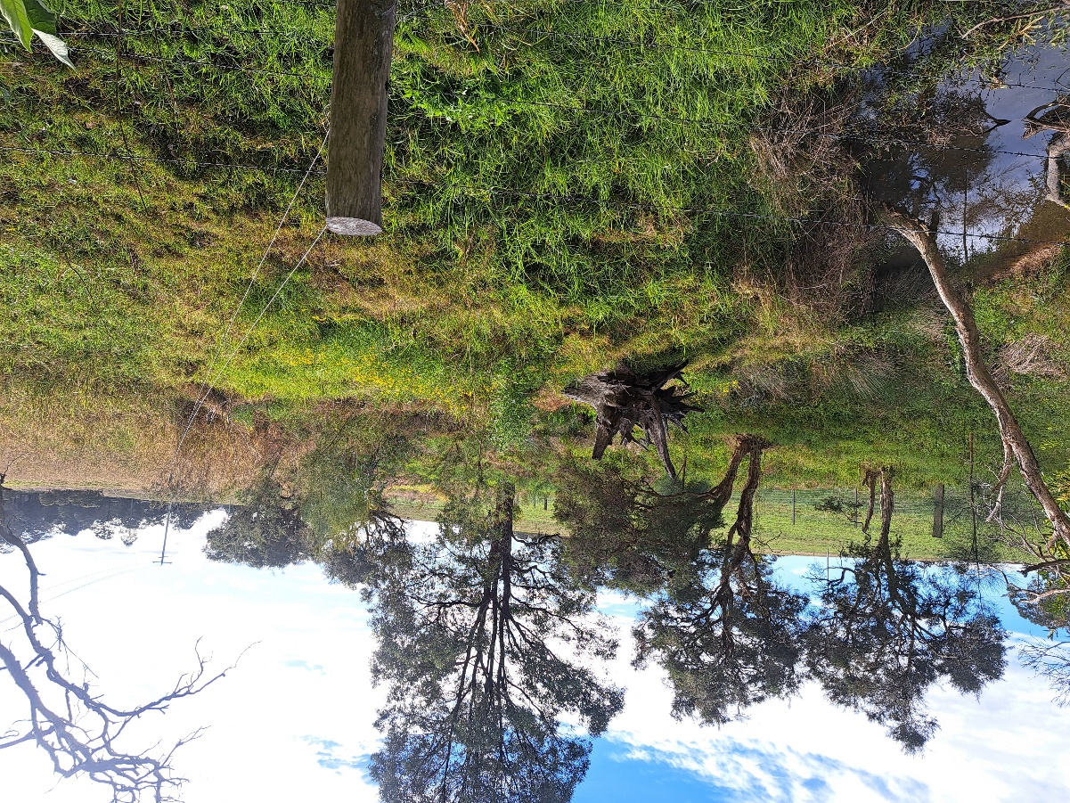
Picture 3. Riparian restoration on water course on the west side of Marshdale Rd
By extrapolating data from Table 4. and information from Land and Water Australia Fact Sheet 13 Manage Riparian Widths (Product Number PF040748) we believe that our actions will be at least 99% effective in minimising nutrient and sediment runoff from the pasture fed chickens.

Pollution Control
There are no known areas where any contamination has occurred.
The farming operation is run using Regenerative Farming practices and therefore there is minimal to non-use of synthetic chemicals such as fertilisers, herbicides or fungicides. The chances of spills or other pollution events occurring are highly unlikely to be nonexistent.

Heritage Conservation
Not applicable
- Flora and Fauna
The proposed areas for the location and moving of the mobile house structures are currently cattle and sheep grazing land with sparsely located native trees. No vegetation will be removed. As per our existing strategy, there will be the addition of native trees to ensure ongoing and sustainable shade for cattle, sheep and chickens and protection of riparian zones along water courses as well as promoting biodiversity and natural sustainability.

Social and Environmental Impacts
The proposed business will be managed by Alan as part of his normal farm occupation and additional casual labour as required. As the expansion to full scale operations (to 2500 birds) is achieved it is likely that a permanent part-time employee will be added to the payroll.
This business is designed to model best practice and innovations in the small scale industry. The intent is to adopt industry best practice as it is identified and act as a hub for continuous improvement. This business will service nearby markets of Dungog region, Maitland and Newcastle with farm fresh, pastured eggs.
- Risk Management

Issue | Monitoring | Record keeping | Management actions and Contingencies
Pasture cover | Weekly visual inspection of range areas | Rainfall records  Range rotation plan  Photographs monthly for 2 years to support decision making re expansion of enterprise | In the event of ground cover reduction increasing the speed of paddock rotations and or range area provided per rotation.  Seek guidance from LLS or DPI if any issues are identified.
Water quality | Annual water testing at on-site run-off areas below the range areas | Rainfall records  Water test results | Maintain range areas 100m from waterways  Maintain vegetative buffers between range areas and waterways  Maintain ground cover at 100% in range areas  Strategically locate poultry houses during periods of high risk- ie predicted high rainfall events  Seek guidance from LLS and/or Hunter Water if any issues are identified.
Soil nutrients | Annual soil testing in poultry production areas | Soil test results | Low stocking density - < 1500 birds /ha  Weekly movement of poultry houses  Non-return period of at least 6 months  Maintain ground cover  Seek guidance from an agronomist if any issues are identified.
Disease and pathogens | Daily monitoring flock health and of mortalities  Salmonella Enteritidis testing every 12-15 weeks | Record of daily mortality  Record of daily egg production  SE test results  Vaccination and health status records | Maintenance of on-farm biosecurity, including per Biosecurity (Salmonella Enteritidis) Control Order  Range rotation  Daily disposal of any mortalities  Immediately seek guidance from veterinarian if changes in flock health, mortality or production are observed
Food safety | Daily compliance with NSW Food Authority requirements | NSW Food Authority Licence and audit results, including all associated records | Seek guidance from NSW Food Authority if any issues are identified.

The approval of this proposal will allow the diversification and increased profitability of this small family farm at Marshdale. We believe Dungog Shire Council should be proudly fostering businesses like Rocking Chair Farm that provide high quality, nutrient dense, clean and green produce to members of our community and promote responsible minimal impact small farming in the Shire.

